

40.016 The Analytics Edge

Project Report
ESD, Term 5, Class 1
Group Name: Insight Edge, Group Number: 6
Student Name | Student ID number
Neo Yew Young | 1004900
Wang Zheng Da | 1007659
Valerie Chua Yu Jia | 1007707
Lalam Venkata Sai Varshitha | 1007878

Introduction
For this problem, we used a combination of XGBoost, CatBoost and multinomial logit to arrive at our result. The training data is passed into each model separately and the results from each model are weighted and normalized such that the sum of probabilities for the alternatives sum to 1 to satisfy the axiom of probability.
Since each model targets the problem in various ways that complement each other, we combined the results of each model in a 70-20-10 weighted average method, before normalizing it. These weights were decided based on the log loss performance on the public leaderboard. This gives us our final model with a Log loss of 1.2245 on the leaderboard.
In the following sections, we will cover on each of the model’s performance on the training dataset and why and how we merged the models to achieve the best result.

1. XGBoost Model
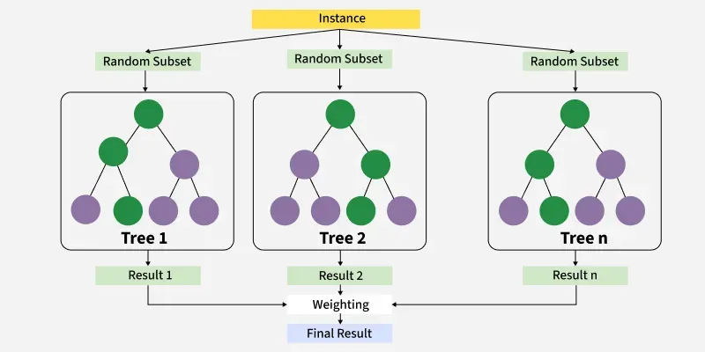
(GeeksForGeeks, 2025)
XGBoost (eXtreme Gradient Boosting) is an ensemble machine learning method used for supervised tasks like classification and regression. It builds a series of decision trees one after another where each new tree aims to improve the model by correcting the errors of the trees before it, controlled by a learning rate, known as shrinkage. These contributions are added together, and over many iterations this process produces a model that reduces bias and with built in regularization helps control variance.

1.1 Data Preparation
We began by cleaning the dataset to remove non-predictive variables such as Case, No, Task, and redundant attributes like gender, age, and income, which stored duplicated information that were present in other attributes provided (for example, ageind and age provided the same information on age). The remaining 91 feature columns were renamed X1 through X91 for compatibility with modelling tools. The target variable which was originally in one-hot format (Ch1 to Ch4), was converted to a column, consisting of an integer categories from 0 to 3, to meet the multi:softprob requirement in XGBoost.
A 70:30 train-validation split was applied, ensuring robust local performance tracking before full-model deployment.

1.2 Model Configuration and Cross-Validation
We used the xgb.cv function with 5-fold cross-validation to determine the optimal number of boosting rounds. The following hyperparameters were selected based on early experimentation and refined via log loss minimization:
- eta: 0.03
  - Eta is the learning rate of the algorithm. At every step, it shrinks feature weightages to make the tree more conservative.
- max_depth: 6
  - Maximum depth of the tree built. Depth = 6 was used to balance modelling more complex relationships against avoiding the risk of overfitting and computation time.
- subsample: 0.8
  - Subsample ratio of the training instance. The algorithm randomly samples 80% of the training data prior to growing trees every boosting iteration.
- colsample_bytree: 0.8
  - Subsample ratio of columns when constructing each tree
- lambda: 1
  - L2 regularisation on weights (ridge regularisation) reduces overfitting by adding a penalty term (sum of squares of coefficients) to the log loss function.
- alpha: 0
  - L1 regularisation on weights LASSO, reduces overfitting by adding a penalty term (sum of absolutes of coefficients) to the log loss function.
The best iteration was selected using early stopping with a patience of 20 rounds. This prevented overfitting and significantly shortened training time.

1.3 Model Training and Evaluation
The model was then trained using xgb.train with the best number of rounds from cross-validation. From each of the 3 model’s predicted probabilities, we weight each model’s result and normalize the result to ensure each row of the combined model’s predicted probabilities sum to 1.

1.4 Feature Selection and Retraining
We extracted feature importances using the built-in xgb.importance() function and retained only those features with Gain > 0.01. This reduced the feature set significantly and simplified model retraining. The reduced-feature model was retrained on the same train-validation split, yielding a slight performance improvement and reducing overfitting risk. Log loss was recomputed post-reduction.

2. CatBoost Model
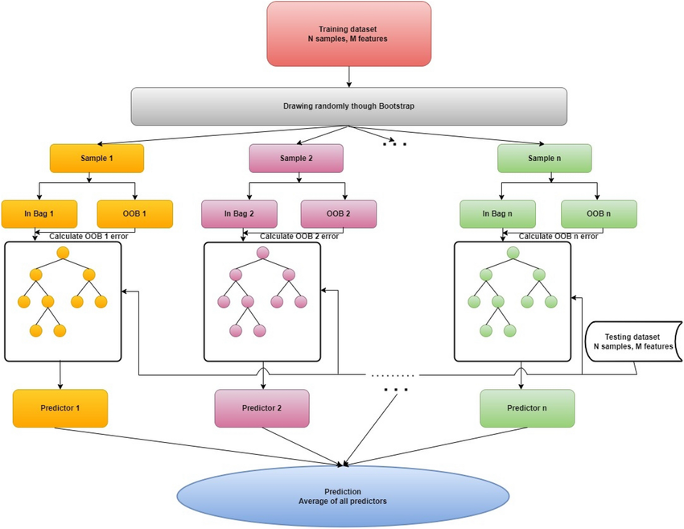
(ResearchGate, 2023)
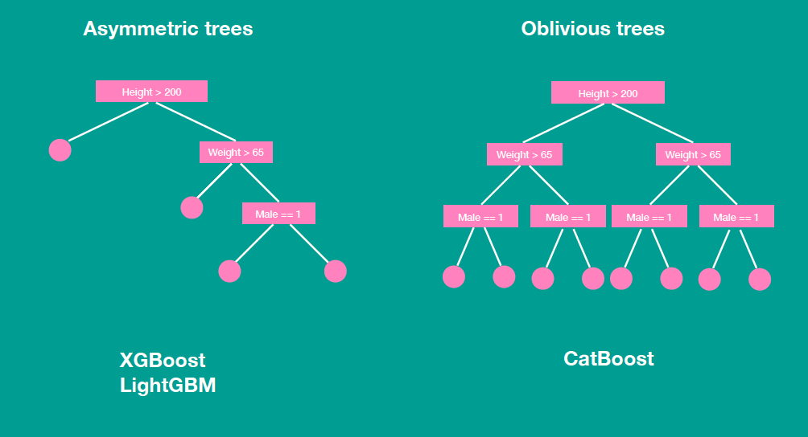
(ResearchGate, 2023)
CatBoost (Category Boosting) is a machine learning algorithm like XGBoost. It works by using gradient boosting, which involves adding new models to fix errors made by previous ones. Unlike XGBoost, CatBoost can directly handle and represent categorical variables. Additionally, CatBoost creates balanced and symmetrical trees as its base models, where all leaf nodes at the same depth follow the same decision rules. This approach can speed up processing and help avoid overfitting.

2.1 Data Preparation and Pool Construction
The preprocessing steps mirrored those of XGBoost. All input features were converted to numeric form as required by the catboost.load_pool() function. The target label was transformed to class integers (0–3), and CatBoost Pool objects were constructed for training, validation, and testing datasets.
We also prepared a full training set (train + validation) for later use in cross-validation and final training.

2.2 Cross-Validation
To optimize the number of boosting rounds, we used the catboost.cv() function with 5-fold cross-validation. The following hyperparameters were adopted:
- iterations: 3333
  - The maximum number of boosting iterations (trees) to build. A larger value was used to compensate for lower learning rate
- learning_rate: 0.015
  - The step size used in updating the model weights during training. A small value was used for better generalisation, and needed a bigger number of iterations due to slower training
- depth: 6
  - The maximum depth of each decision tree. Depth = 6 was used to balance modelling more complex relationships against avoiding the risk of overfitting and computation time.
- l2_leaf_reg: 5
  - Ridge regulation: Helps prevent overfitting by penalising large leaf values. A higher value increases regularisation
- random_strength: 1
  - The amount of randomness applied to scoring splits (Used for symmetry breaking and better generalisation. This adds stochasticity to the model, which can help reduce overfitting.
- bagging_temperature: 1
  - Controls the sampling probability in Bayesian bootstrap (used for data sampling in each iteration). 1 is a balanced default value between more deterministic sampling (closer to standard bagging) versus more random, more aggressive sampling.
- od_type: "Iter"
  - Overfitting detector type. "Iter" stops training if the validation metric hasn’t improved for od_wait iterations. Helps prevent overfitting and saves training time by stopping early.
- od_wait: 20
  - Number of iterations to wait after the last improvement before stopping training (used with od_type = "Iter"). If the model doesn't improve for 20 iterations, training halts early.
The best iteration was selected based on the minimum average log loss across folds.

2.3 Training with Early Stopping
Using the best iteration from cross-validation, we trained the CatBoost model with early stopping on the validation set. Predicted probabilities were extracted using catboost.predict() and evaluated using log loss, as in the XGBoost pipeline.
Here, stopping early prevents overfitting while avoiding substantial worsening of the log loss values.
Model | Iterations  (No stopping) | Iterations  (Early stopping) | Log loss  (No stopping) | Log loss  (Early stopping)
CatBoost | 3333 | 2945 | 1.09335 | 1.09551

2.4 Feature Importance and Model Reduction
Feature importances were retrieved using the ‘PredictionValuesChange’ metric. Features with importance > 0.01 were retained, and the model was retrained on this reduced feature set. Validation log loss was recomputed post-reduction and showed consistent performance with the full model while offering improved interpretability due to the fewer number of variables used.
Model | Features (Full) | Features  (Reduced) | Log loss  (Full) | Log loss (Reduced)
CatBoost | 94 | 71 | 1.09551 | 1.09351

3. Multinomial Logit
The team deemed that a choice model – such as multinomial logit – would be appropriate here as in each choice task of this problem statement, the customer must make a choice among four packages. However, we believe that the independence of irrelevant alternatives (IIA) assumption is not clear here as each choice bundle may contain the same features but at different levels, which may affect the independence of how customers view the packages. For example, if the option with the cheapest price is removed, customers who initially chose that option because of its price would likely choose the second cheapest option instead of proportionately splitting their choices to the other options.

3.1 Data preparation
To implement a multinomial logit method, we must make use of R’s dfidx command. The command will split the dataset into “train” and “test” segments by the Task column, converting the data frame from a wide to a long format by expanding each row observations containing 1 choice task and 0-1 for 4 different choices into 4 different rows each with their own choice, which allows us to use the mlogit fit.
We then remove individual specific variables that are not related to the car’s features such as ‘income’, ‘age’, ‘gender’ and keep only alternative specific variables that end with 1-4 (e.g. CC1) for our prediction model.

3.2 Training considerations
We trained the model by subsetting the data using the Task variable from 1-12 as the training set. Since the choice tasks are self-contained and the choice tasks are not fixed between persons, and there is no need to capture any individual preference from the data since the objective is to build a general model, we chose to split by task and not by individual (i.e. Case).
When training the model, we chose to leave out alternative specific constants because each alternative-specific variable (i.e. Variables that end with 1-4) included in our model indicate different safety features of the car. This is a very subjective variable that can differ from person to person. Since the data is survey data taken by different customers, and the test data where we evaluate our model is another different set of customers, it makes sense to not assume and model a fixed constant to any variable that is not universally valued/disliked by all customers without first having that information, which was not given to us.

3.3 Performance
The multinomial logit’s log-likelihood is a globally concave function of the parameters, because each choice term involves a concave “log-sum-exponential” component whose Hessian is positive semi-definite. This means that minimizing the negative log-likelihood is therefore a convex problem—any stationary point is guaranteed to be the global minimum and is therefore one of the strengths of using multinomial logit.
The model performed very well using this split, achieving a log loss of 1.16 on the test set. However, we then felt that this model could be overfitted to the training data. To balance out the bias towards the training set, we looked towards the other machine learning techniques and would eventually create a weighted ensemble method.

4. Description of Results

4.1 Validation Performance
The validation log loss scores (using 30% of the training set provided) for the individual models were as follows:
- XGBoost: 1.06026 (full and reduced feature sets combined)
- CatBoost: 1.09351 (full and reduced feature sets combined)
- Multinomial Logit: 1.16
These scores were computed on the held-out validation set after training on a 70% subset of the data. All three models demonstrated strong predictive performance, with XGBoost outperforming CatBoost and Multinomial logit in internal validation.

4.2 Test Set Performance on Public Leaderboard
- XGBoost only: 1.3058
- CatBoost only: 1.2336
- Multinomial Logit only: 1.2559
- Final ensemble model: 1.2245 (Most improved)

4.3 Qualitative Insights
- The ensemble approach provided a noticeable performance gain compared to any single model.
- Feature importance filtering (selecting variables based on importance thresholds) had mixed effects:
  - For XGBoost alone, filtering slightly worsened the validation log loss. This feature was originally intended to improve interpretability and ease for application of model. However, it may have worsened results for XGBoost alone by removing inter-feature dependencies which XGBoost relies on.
  - Combining the three individual models in a weighted average method contributed to improved generalization and model stability, which eventually played a role in reducing log loss values in the public leaderboard.

5. Interpretability and Limitations

5.1 XGBoost

Interpretability and Strengths:
- XGBoost provides feature importance metrics such as Gain, Cover, and Frequency, which help identify influential variables easily.
  - Gain: The average improvement in loss (E.g. log loss, RMSE) when a feature is used to split the data. It measures how much a feature contributes to reducing error in the model. Features with high Gain mean that they are more influential in improving model accuracy and is best for understanding which features have the greatest impact on predictions.
  - Cover: The average number of samples affected by splits using the feature. It measures how broadly a feature influences decisions across the dataset. This means that high Cover means a feature is used in splits that affect many data points and is best for understanding features with widespread influence, even if the gain is small.
  - Frequency: The number of times a feature is used in all the trees (raw count of splits). It measures how often a feature is used in tree branching. High frequency means that the model relies often on that feature, but not necessarily that it is the most important, and is best for identifying commonly used features.
- Partial dependence plots (not shown here) can be generated to explain marginal effects of top features.
- Tree-based models offer some degree of local interpretability through decision paths.

Limitations:
- Complex ensembles of decision trees make it difficult to intuitively understand how individual predictions are made.
- The model treats all input features as numeric and independent, which may obscure interactions unless explicitly engineered.
- XGBoost is prone to overfitting if hyperparameters are not properly tuned, particularly with many features.

5.2 CatBoost

Interpretability and Strengths:
- CatBoost supports built-in tools for feature attribution (PredictionValuesChange), enabling straightforward variable ranking.
- Unlike XGBoost, CatBoost natively handles categorical features (not used in this setup but available).
- The model's monotonicity constraints (not used here) can further enhance explainability in future extensions.

Limitations:
- Interpretation of learned feature interactions requires complementary tools (e.g., SHAP) to fully explain model behavior.
- Feature importances may vary across cross-validation folds, especially in the presence of correlated or sparse features.
- While more accessible than deep learning models, CatBoost still functions as a “gray box” at prediction time without additional explanation layers.
- For large datasets like the one provided, CatBoost can consume a significant amount of memory.

5.3 Multinomial Logit

Interpretability and Strengths:
Multinomial logit has certain properties that make it interpretable such as:
- The concept of willingness to pay gives users a trade-off ratio between different features, potentially helping the business understand how customers trade-off between the different packages.
- Coefficients have clear interpretations as changes in log-odds.
- Simple, transparent model structure with no hidden layers.

Limitations
- Assumes IIA, limiting interpretability with similar/correlated choices.
- Interpretation depends on the chosen reference category.

6. References
Chepenko, D. (2019, February 14). Introduction to gradient boosting on decision trees with catboost. Medium. https://medium.com/data-science/introduction-to-gradient-boosting-on-decision-trees-with-catboost-d511a9ccbd14
GeeksforGeeks. (2025, July 23). XGBoost. GeeksforGeeks. https://www.geeksforgeeks.org/machine-learning/xgboost/
Ibrahim, M. (2025, May 15. Understanding L1 and L2 regularization: techniques for optimized model training. Weights & Biases. https://wandb.ai/mostafaibrahim17/ml-articles/reports/Understanding-L1-and-L2-regularization-techniques-for-optimized-model-training--Vmlldzo3NzYwNTM5
Kolli, A. (2024, February 13). Understanding CatBoost: The Gradient Boosting Algorithm for Categorical Data. Medium. https://aravindkolli.medium.com/understanding-catboost-the-gradient-boosting-algorithm-for-categorical-data-73ddb200895d
(n.d.). XGBoost Parameters. https://xgboost.readthedocs.io/en/stable/parameter.html
Tyagi, A. (2025, Apr 23). What is XGBoost Algorithm?. https://www.analyticsvidhya.com/blog/2018/09/an-end-to-end-guide-to-understand-the-math-behind-xgboost/
Structure of catboost algorithm | download scientific diagram. (2023, August). https://www.researchgate.net/figure/Structure-of-CatBoost-algorithm_fig3_372827215

